BugTracking

Management System



Prepared By:

Ajay Kumar Mukhi (A20392100)

# 

**Table of Contents**

Project Definition 3

Project Workflow 4

Project Screenshot 5

Welcome Page 5

Registration Page 5

Login Validation Page 6

Home Page 8

User Control Management Tab 9

Employee Tab: 11

Project tab: 12

Department tab: 13

Bug Tracking tab: 14

Report Management 15

User-Employee Management 18

Setting tab: 20

Logout Screen: 21

# **Project Definition**

Software industry deals with the development of software applications/systems. With the development of software applications/systems, there also comes a phase during software development in which company needs to test application/systems before delivering it to end client. With keeping this idea in mind, I have chosen to develop Bug Tracking Software for any specific company.

Big Tracking Software will help developers and their team to solve the bugs associated with the application/system. This software will help them to track the bugs associated with the different modules and based on it resolve it.

This system will comprise of the different users such as Manager, developers, testers. Each user will have feature to register and login into the system. Once they get registered into the system, managers can create projects and add its information. Each tester user can report bugs associated with any specific module and then assigned back to the respective developer. Based on the feedback provided by tester, developer will resolve bugs and update its status on the system. Manager can view several types of reports and filter it according to week, month, year.

So using this system, company can keep track of bugs associated with any project and deliver bug free software to their clients.

**Roles :-**

**1) Administrator**

Administrator will take care of all registration status, profile management and provide privileges to manager and employees

**2) Manager**

Manager will take care of onboarding of employees into the project and assigned task to the employees. Manager will not only manage the employee but also monitor the bugs reported by the tester.

**3) Employee**

Employees are of two types, developers and testers.

Tester will create the test plan and raise the bug if any found in the system. So tester will create the bug report and assigned to the respective developer.

Developers will develop program and resolve the bug if assigned to them and update the solutions and status of the reported bug into the system.

# **Project Workflow**

Below is the project workflow of the overall system:

My Profile:

Update

Bugs:

Add/Update/Delete

Registration Module

Login

Add Departments

Add Project

Add Employee

Reports

Add /View/Edit/Delete Report

Generate Report

Permission

# Project Screenshot

**Welcome Page**

**Description:** The welcome page is having the Login and registration link.For a new user he has to click on the Create an Account link and then do registration.

**Screenshot:** Below is the Login page for All the users (Admin,Manager,Employee)

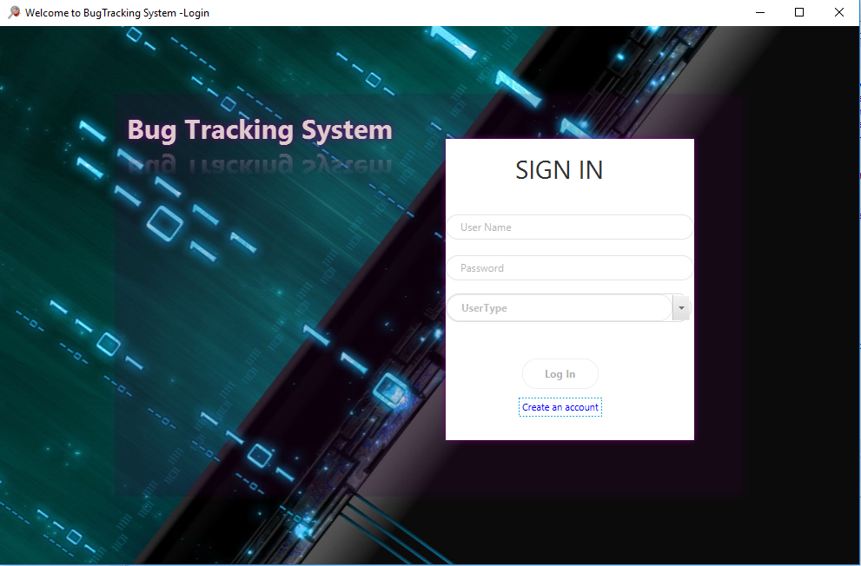

**Registration Page**

**Description:** Except Administrator, all other users needs to registered into the system.The registration page will asked the user to fill the fields like username ,full name,password and re enter-password,usertype,emailaddress and contact number. The required validation has been done to take care the mandatory fields.Untill these mandatory fields are not provided by user ,the sign up button wouldnot be enabled.

**Screenshot:** Below is the Registration page for both Manager & Employee.

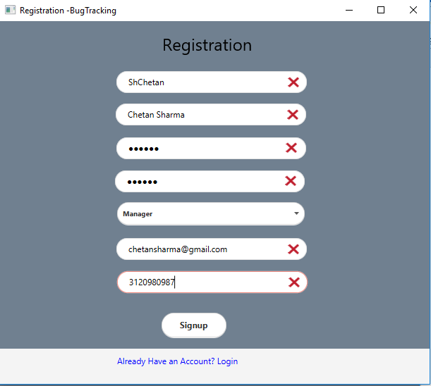

## **Login Validation Page**

**Description:** The Login page will ask the user to fill Username, password and user type.

There are two validation maintained while login into the system.

1) The validation has been done for username and password if not matched to stored values in the database. It will throw the error.

**Screen Shot:** Below is the screen shot for the validation of Login Page.

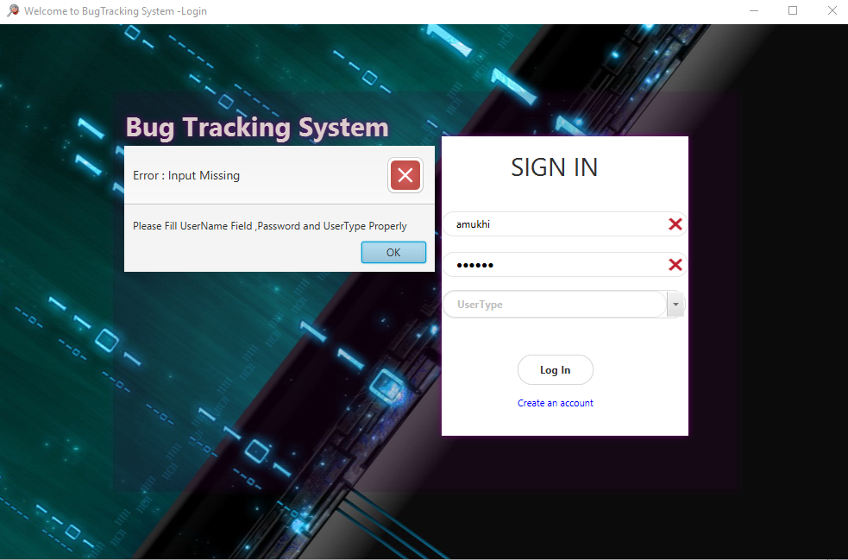

2) If Password not matched that is stored in the database.

**ScreenShot:** Below is the screenshot showing the validation for password mismatch

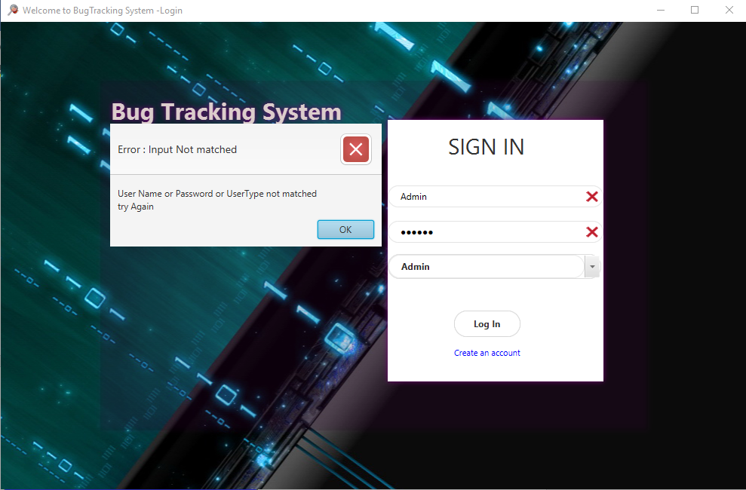

Once Login with correct credentials ,the user can see the home page.The system will behave and show the functionality as per the profile of the user and user type.

# **Home Page**

There are two home page maintained for the user in the system.

1) Admin/Manager Home page.

2) Employee Home Page

**Description**

1) Admin/Manager Home page- The admin and manager would be having same privileges and view the common home page .The home page will show the how many department,projects user level employees defects and etc. They are having the privileges to view usercontrol management, report management screen ,user-Employee Screen,Setting Screen in the dashboard.

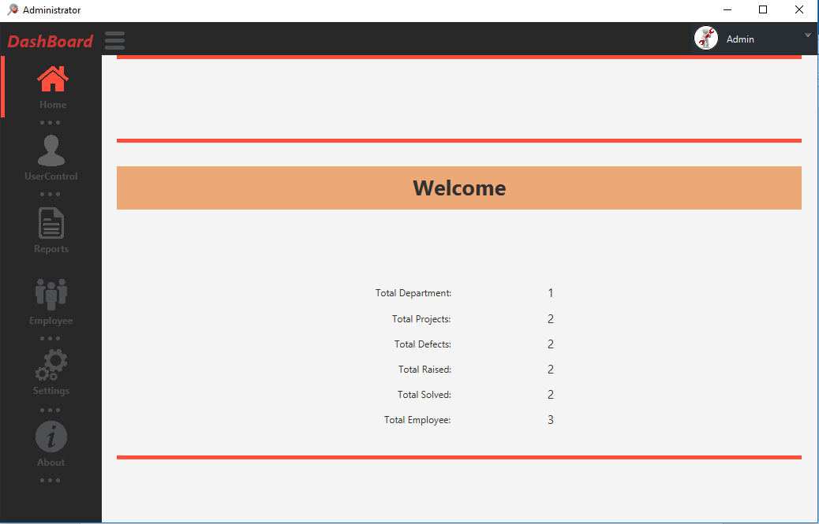

2) Employee Home Page

**Description:** The employee home page will show number of defects, how many raised and resolved. Employee do not have the privileges to view the Employee tab in Dashboard.

Regarding the Report, only Tester can view it which can be done by setting the permission.

**Screen shot:** Below is the screen shot for the same.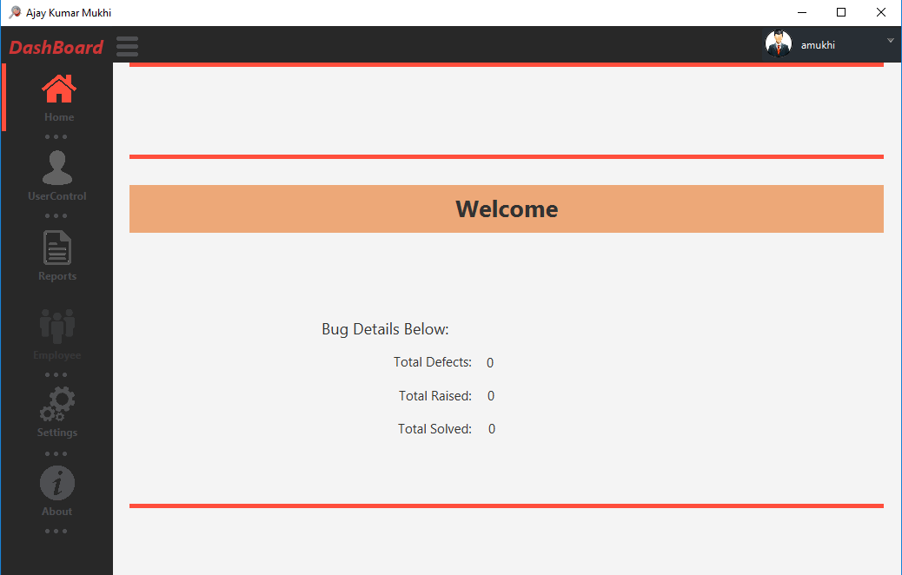

# **User Control Management Tab**

Under this panel, there are 4 main functionalities where User can work with.

Employee tab, Project tab, Department tab, Bug Track tab.

**Description:**

1) Admin/Manager: They have the privileges to perform Add/Update/Delete on all the above functionalities.

Manager will perform the onboarding of user level employees into the project and assigned role to them. Based on the role, Bug can be assigned to Developer employee.

**Screenshot:** Below is the screen for Admin/Manager.

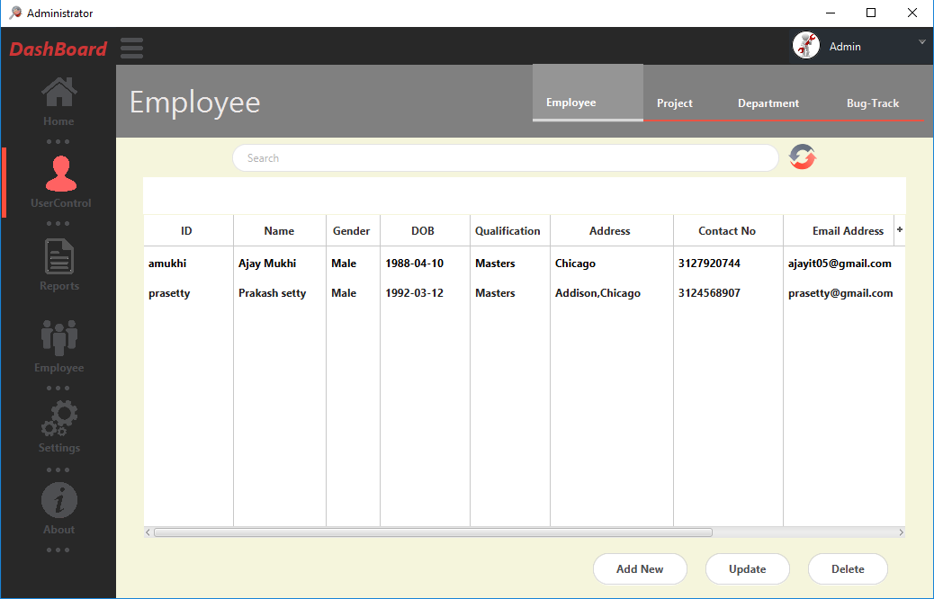

**2) Employee:** For Tester and Developer, only the Bug tracking tab is accessible. They can add/update/delete for Bug tracking functionality.

For all other functionality/tab he can view the records but cannot perform any operation.

**Screenshot:** Below is the screenshot for the same.

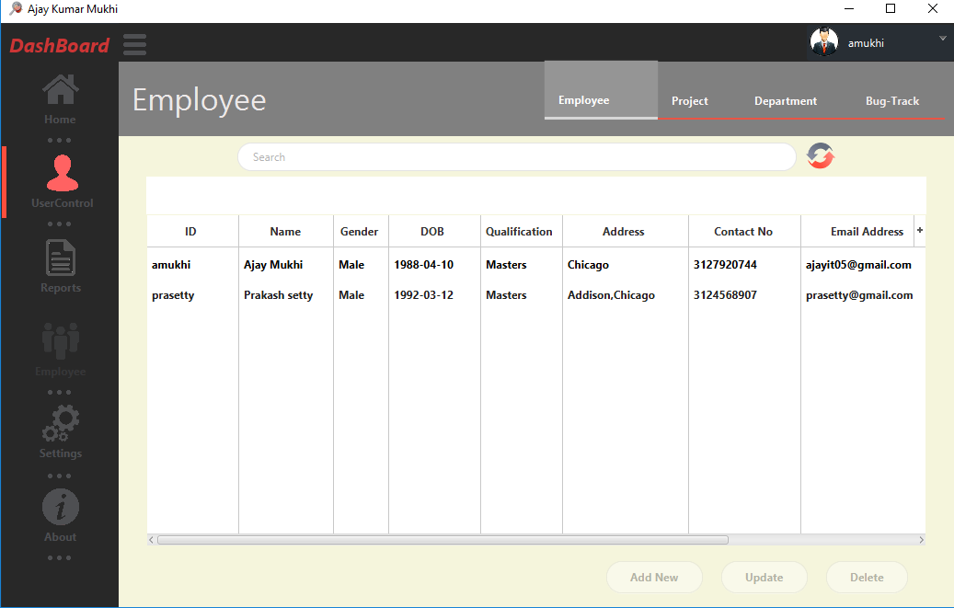

## **Employee Tab:**

**Description:** Manager can perform various functions. For example, user level Employee will be added by manager for the project and bug tracking.

**Screen shot:** Below is the screens hot for the same.

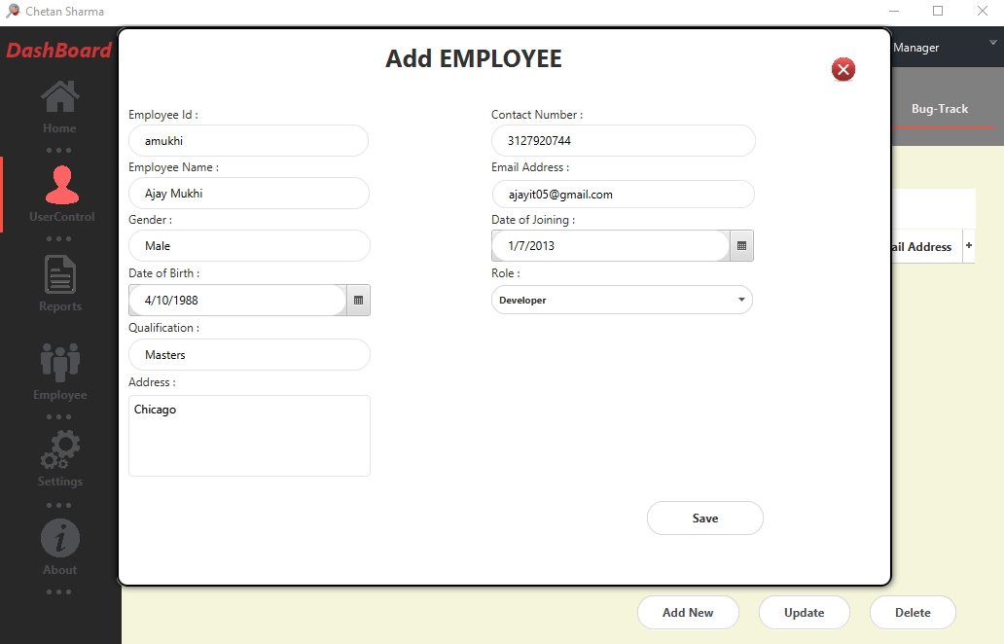

Manager can Update and Delete the Employee as well.

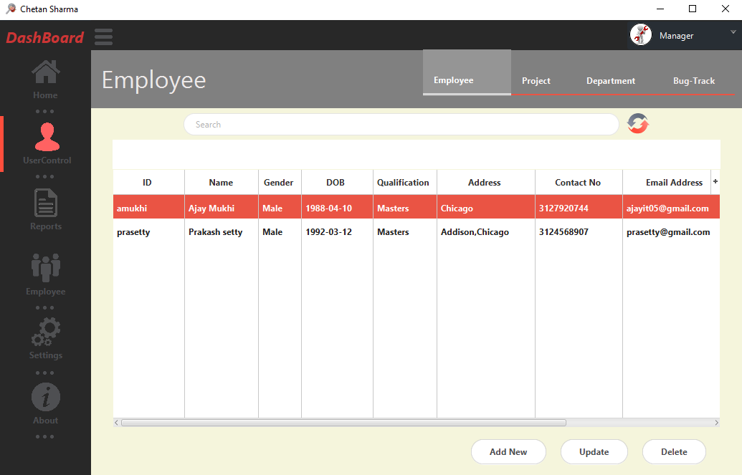

## **Project tab:**

**Description:** Manager/admin can add, update and delete the project from user control tab.

**Screenshot:**

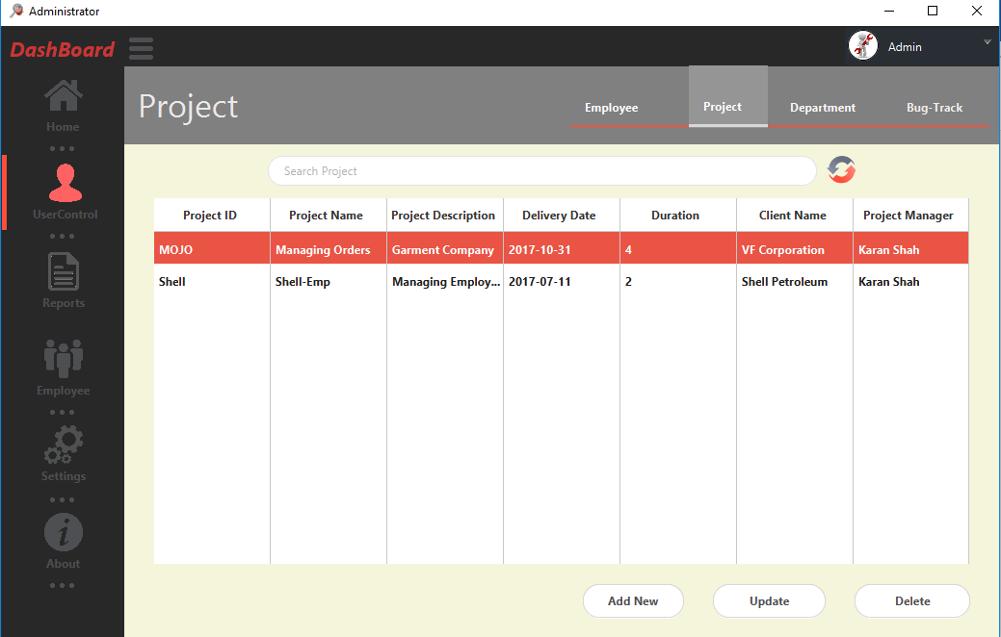

## **Department tab:**

Manager and Admin will be having the privileges to add/update/delete department.

**Screen shot:**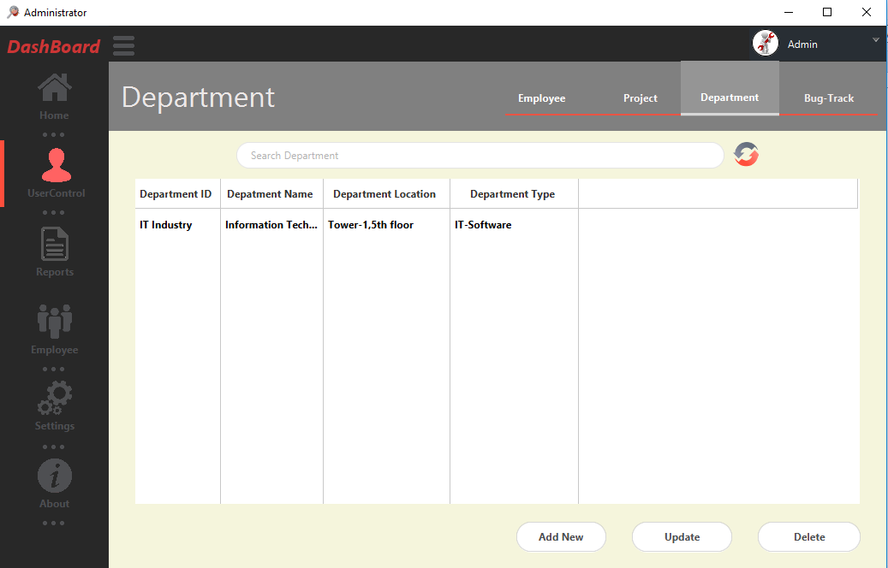

## **Bug Tracking tab:**

**Description:** Bug Tracking is managed by both Manager and Employee. Both user will have add/update/delete button enabled in the system.

**Screenshot:** Below is the screenshot

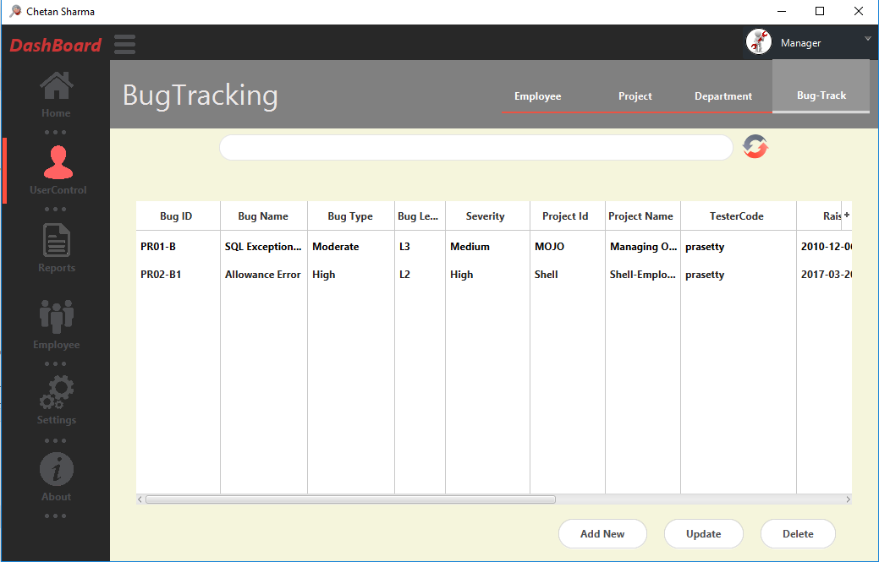

# **Report Management**

**Description:** All the user will have the privileges to access the report management.

Manager will add/update or delete the report whereas employee can only view the report system.

**For Admin/Manager:**

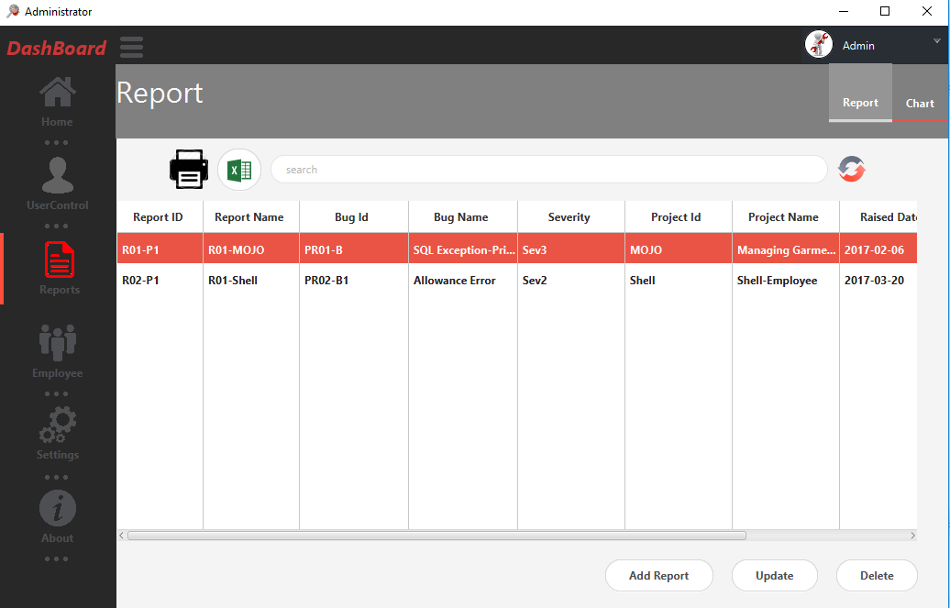

**For Employee:**

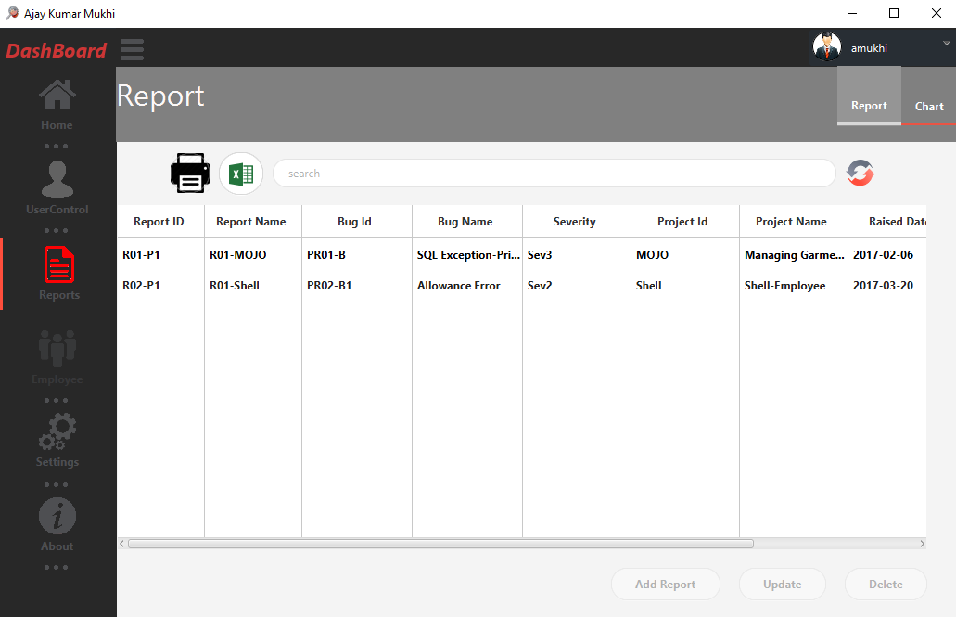

**Report tab**

Report Can be generated on click of print button and xsl icon button.

Jasper Report Generation: with the help of Jasper api, the report generation has been done in this system and it can be saved into desktop as pdf version. The XSL version report also can be downloaded into the desktop.

**Screenshot:**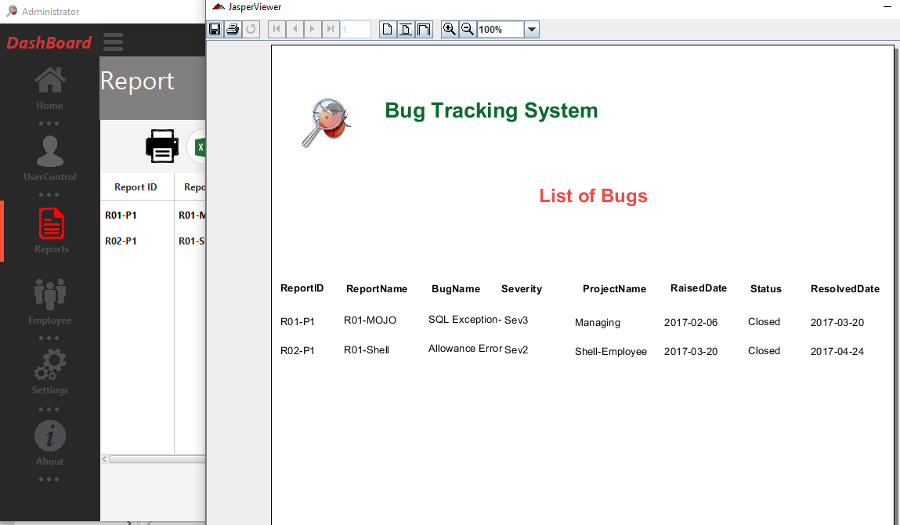

**Bar Chart**

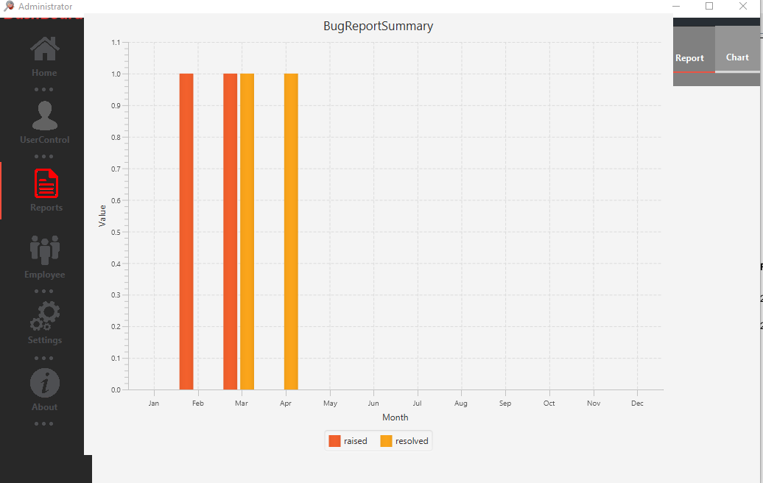

# User-Employee Management

**Description:** Only Admin and Manager will be having the access to the Employee Management tab. Here the manager can edit the profile of the employee and also set the permission for it.

**Screen shot:**

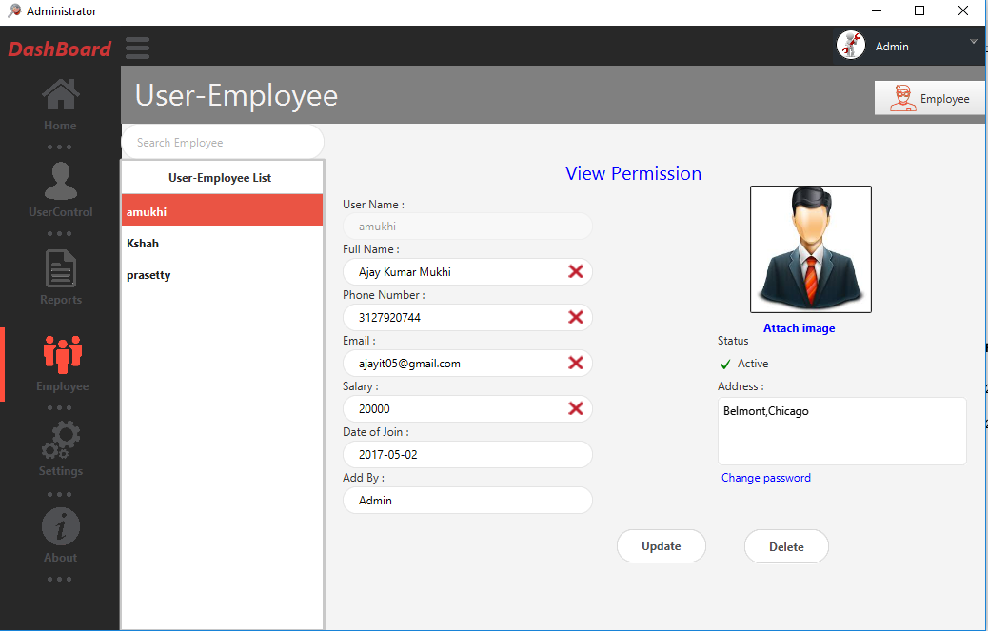

**User-Employee Permission:** The manager can set the permission for each individual employee. So when the Employee will logged in first time they can access everything. But the Manager will set the permission which ever functionality is required to be provide.

**Screen shot:**

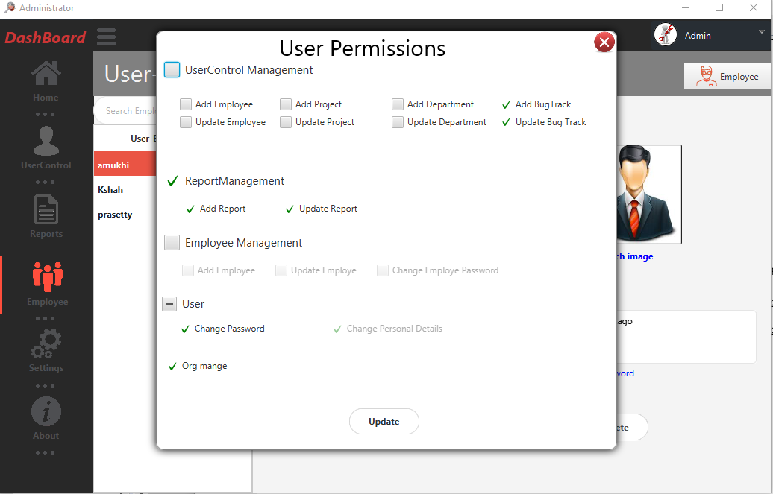

# **Setting tab:**

**My Account**

**Description:** In the setting tab, each user will have the privileges to edit or update the account.

**Screenshot:** 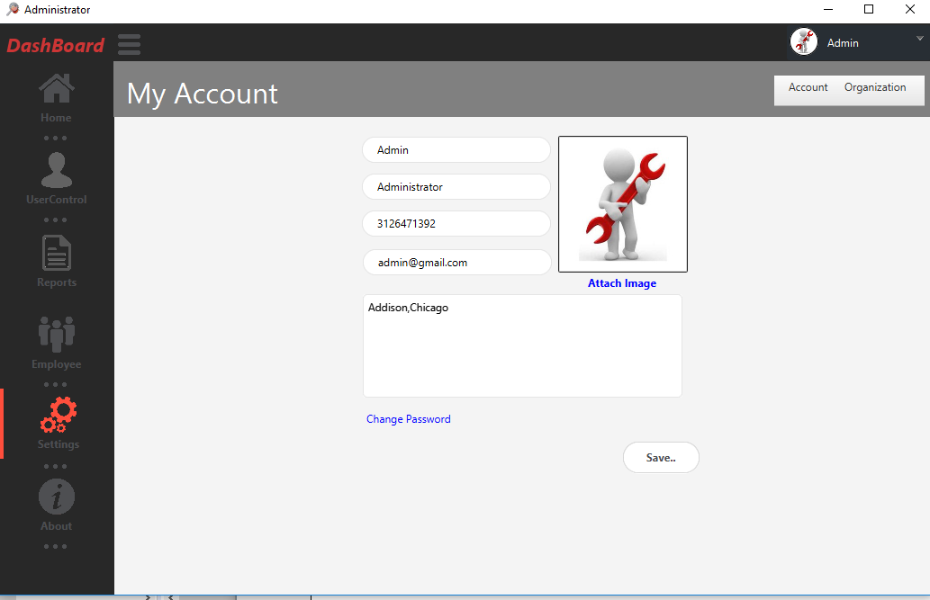

# **Logout Screen:**

Once the user logout, the user will be redirected to the welcome page.

**Screenshot:**

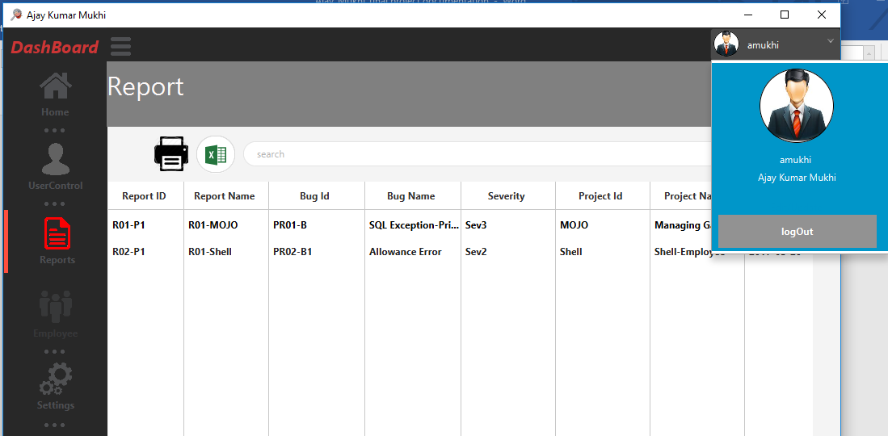



**Admin credentials:**

User Id -> Admin

Password -> admin

Select the UserType as Admin.